Chapter – 8: Force and Pressure

* Daily activities – opening door, kicking football, opening drawer – require push or pull

# Force

* External agent – push or pull
* Force – particular direction
* Amount of force – **magnitude of force**
* Direction – force applied – **direction of force**
* Pulling drawer out – force towards ourselves
* Pushing door close – force towards door
* International system of units – unit – Newton (N)
* Other units – dyne, kilogram force, pound force
* Force – interaction between 2 objects
* Long piece of rope – cannot move by itself – children – playing tug of war – ropes move in both direction
* Force – applied in different direction – resultant force – difference of magnitudes – direction of greater force – equal force – resultant force – 0
* Force – applied in same direction – resultant force – sum of magnitudes – same direction

# Effect of force

* Force can change speed of moving object or move object at rest
  + Apply brakes – opposite direction of moving car – slows down car
  + Press accelerator – force applied – same direction – car speeds up
  + Playing cricket – stopping ball
  + Playing football – move stationary ball
* Force can change shape of object
  + Squeeze tomato – gets smashed
  + Squeeze toothpaste – shape of tube change
  + Change – temporary or permanent
  + Shape of sponge changes when pressed – shape of dough changes when pressed – shape of metal sheet changes when hammered
* Force can change direction of motion
  + Tennis racquet – change direction of ball
  + Change direction of motion – apply force in different direction
* Force – push or pull
* Changes – state of motion and/or shape of object
* State of motion – speed and direction

# Types of force

* Force – push or pull – interaction between forces
* Categorized as – **contact** and **non-contact**
  + Non-contact forces –
    - Interacting bodies – not in contact
    - Act from distance

## Gravitational force –

* + - * Throw ball upwards – reaches a fixed height – falls down immediately
      * Reason – earth applies force – pulls ball back
      * This force – **gravity**
      * 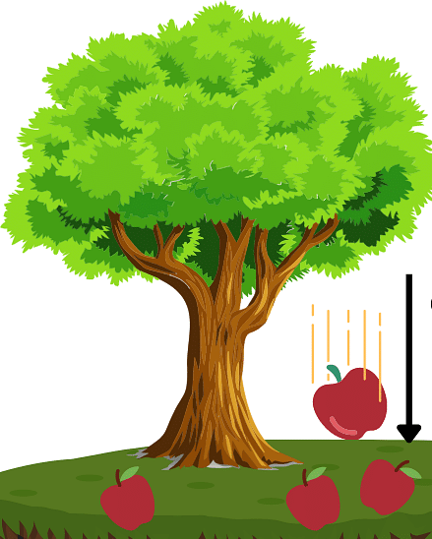**Sir Isaac Newton** – observed earth’s gravity – 1st time
      * Every object – applies force on each other
      * Magnitude – depends – directly on product of masses – inversely on square of radius
      * Gravity of sun – all planets revolve around it
      * Mass – material of object – weight – force on object due to gravity
      * 3 kg apples – mass – same on earth and moon – weight – more on earth and less on moon
      * Weight – can be measured with spring balance
      * Hold a brick – after some time – hand feels heavy – gravity pulls the brick – muscles fight with gravity to keep holding it

## Electrostatic force –

* + - * Comb your hair – hold the comb over your head – hairs stick to comb
      * Comb – gets electric charge – charged body – applies force – other charged on uncharged body
      * Charged comb – attracts piece of paper
      * 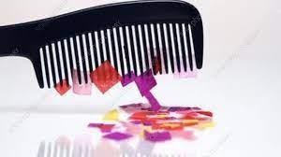Rub balloons on sweater – stick on the wall

## Magnetic force –

* + - * Magnet – attracts other magnetic substances
      * Cranes – lift heavy objects, separate iron from garbage
      * Magnet – near iron fillings – attract them

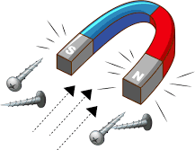

# Pressure

* Contact forces –
  + Interacting bodies – always in contact
  + Different bodies – sliding against each other

## Muscular force –

* + - Applied by muscles of body
    - Kick football – muscles of leg
    - Lift school bag – muscles of arms
    - Oxen, camel – use muscles – pull carts with people and goods

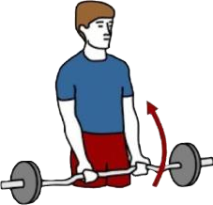

## Frictional force –

* + - Stop peddling – cycle stops
    - Force applied on objects in contact – opposite to direction of motion – **friction**
    - Opposes the motion of objects

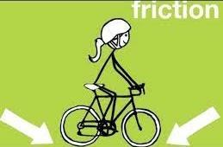

* + - Effects of force – depends on – not only on magnitude – but also on area over which it acts
    - Flat sandals – soft impressions – heels – deep impressions
    - Force acting per unit area
    - Pressure = force/area
    - Less area – more pressure and vice-versa
    - Stand on bed – bends more – lie on it – bends less
    - Blunt knife – difficult to cut – sharp knife – easy to cut
    - Blunt side – more area – less pressure – sharp side – less area – more pressure
    - Women – carry mud pots – place cloth on head – increase area
    - Men – carry luggage on stations – place cloth on head – increase area

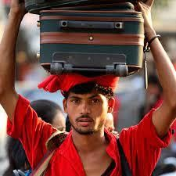

* + - Nails – pointed end – less area – hammered easily

## Unit of pressure

* + - SI system – force measured in Newton (N) – area measured in metre square (m2)
    - SI unit of pressure – Pascal (Pa)
    - 1 Pa = 1 N/m2
    - Some things – high pressure – work well – scissors, bolt-cutters, knives
    - Other things – low pressure – work well – tractors, vehicles that move over mud

# Pressure exerted by air

* + - All fluids (liquids and gases) – exert pressure
    - Fill balloon with air – it expands – pressure by air on the walls
    - Keep filling it – at a stage, it bursts
    - Pressure by atmospheric gases – **atmospheric pressure**
    - Atmospheric pressure at sea level – **normal** or **standard pressure** – 100 kilo pascals (100 kPa)
    - Pressure on our head – column of air over it – equal to force of gravity on 225 kg – 2250 N
    - This pressure – too much – we don’t feel it – pressure by blood in blood vessels – balances it
    - High altitudes (heights) – low atmospheric pressure – same blood pressure – bleeding through nose and ears – blood vessels rupture
    - Instrument – measure atmospheric pressure - **barometer**

# Pressure exerted by liquids

* + - Tie a balloon – end of hollow glass tube – fill it with water – balloon expands – **liquid exerts pressure in all directions**
    - Take a jar – make a hole at bottom – attach a pipe – tie a balloon at the end – fill it with water – balloon expands – **liquid exerts pressure on walls**
    - Take 2 jars – 1st – make holes at equal depths – 2nd – make holes at different depths – fill them with water – 1st – flow rate of water same at all holes – 2nd – flow rate of water different at different holes – more at lower holes – less on higher holes – **liquid exerts different pressure at different depths**
    - 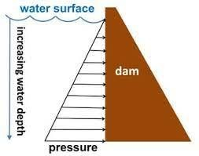Dams – store water – dam walls – built wider at bottom – more pressure by water

# Measurement of pressure

* + - Air pressure drops – tyres of vehicles – fill it up again – keep eye on machine – more air pressure – tyres may burst
    - **Barometer** – measure atmospheric pressure
    - Long tube (sealed at one end) – filled with mercury (Hg) – inverted into a tray of mercury
    - Sea level – atmospheric pressure – pushes mercury in tray inside glass tube
    - Height of mercury in the tube = atmospheric pressure
    - Higher altitudes – less height – low pressure
    - 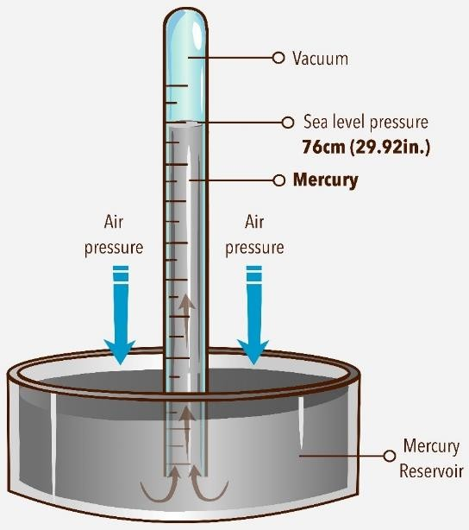Standard – 760 mm of Hg

## Can we use water instead of mercury?

* + - Water less dense – level of water – rise too much – very long glass tube required – barometer – bulky and impractical
    - Another instrument – **U-tube manometer**
    - Measure difference – pressure by atmosphere and pressure by other fluid
    - Simple manometer – u shaped glass tube – filled with coloured water
    - One end – open to atmosphere – other end – connected to container of fluid
    - If atmospheric pressure > pressure of fluid – level of water in closed end – rise
    - If atmospheric pressure < pressure of fluid – level of water in open end – rise
    - If atmospheric pressure = pressure of fluid – level of water in both ends – same
    - 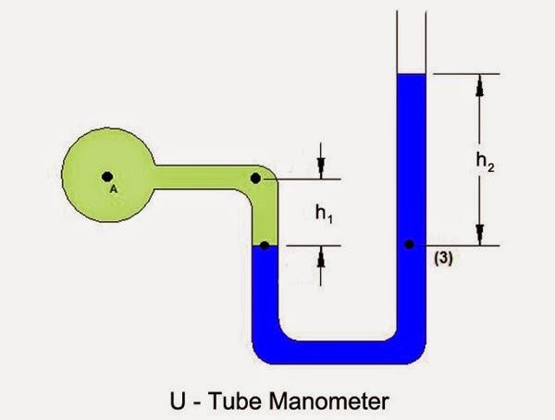Pressure difference = h2 – h1

# Application of pressure

* + - Pressure by liquids in blood vessels – blood moves throughout the body
    - Rubber suckers – air inside them is sucked out – held against the wall by atmospheric pressure
    - When juice is sucked through straw – air in straw goes to lungs – reduces pressure inside straw – liquid gets filled in straw
    - Vacuum cleaner – switch on – low pressure inside it – sucks dirt inside it
    - Squeezing of tooth paste, spray bottle, ketchup – work due to pressure difference